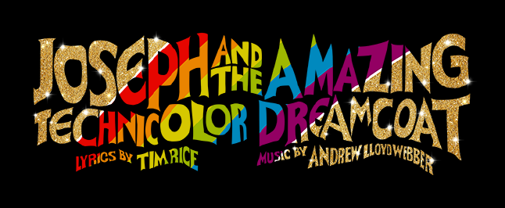

Personal / One-Liner Ad Form

Patron or personal ads are $5.00 for 15 words or less. Over 15 words is $1.00 for every five additional words. Ads will not be accepted without payment. Please type or print legibly.

Name

Telephone Number

Payment Received

Amount $

Ad #1:

Ad #2:

Use the back of the form or a separate sheet for additional ads.

Thank you for your interest in our program. All patron ads are due no later than July 10th and can be emailed to kodonnell@easternsavingsbank.com AND kari_odonnell@yahoo.com. OR handed to Kari O’Donnell. Please contact Kari at 443-386-0152 if you have any questions.

(See samples on reverse side.)

Sample Patron Ads

Kate – Congratulations, best of luck and have fun! You have always been our “star.” Love, Mom and Dad

To Homero, Chris, Jesse, Carol and Susie – Thanks so much for all your help and another GREAT show! “Break a leg!” to the entire cast! XXOO

Molly, Hugh & Ryan – Thank you for traveling down the Yellow Brick Road with me! - John

Em, I have always seen you in my future -Chester (Marvel)

Mom - Congratulations—you are officially a theatre geek :) Break a leg, Oh Stage Manager Extraordinaire! Love, Molly

Homero, Karen, Kari, Jo-Anne, Matt and Suzi – Thank you for a great summer ! – Eric

Megan - My partner in crime, one of my best friends in the WORLD, and my beautiful sister. Six consecutive GAP shows and counting— Olé! Love you girl, Molly

Emily – you have a bright future somewhere over the rainbow. We love you – Mom

Dear Spencer, Break a leg. We are so proud of you. Love, Grandma and Grandpa

Mary Catherine – you are our shining star !!! We love you very much – Grandma and Grandpa

Elena – congrats on another GREAT production, your hard work and dedication really show !
- Mom & Pop

Jenny, Congratulations on another great production ! Love Grandma and Grandpa

Olivia – Look out Broadway ! Here you come ! You can count on us being in the audience. Love, G

